Hospital Database Design And Implementation

BY

FREGENE JOSEPH ORITSETSERUNDEDE

SEPTEMBER, 2024

Hospital Database Design And Implementation

Project Overview

This repository contains the Database Design and Implementation project For joseph Hospital patient and Medical Management System, Completed by Dede Analytics in september 2024. the System is design to efficiently manage hospital data, including patients information, doctor details, medical records, appointment and department data.

Table of Content

1. Introduction.

2. Database Design process.

- Requirements Gathering.

- conceptual Design.

- Logical Design.

- Physical Design.

3.Database Schema and Implementation.

- Patients Table.

- Department Table.

- Medical Record Table.

- Doctors Table.

- Appointment Table.

4. Normalization.

- First Norm Form.

- Second Norm Form.

- Third Normal Form

Justification of Design Choice.

Introduction

This repository contains the Database Design and Implementation project For joseph Hospital patient and Medical Management System, Completed by Dede Analytics in september 2024. the System is design to efficiently manage hospital data, including patients information, doctor details, medical records, appointment and department data.

Joseph Hospital requires a Scalable efficients solution to manage its healthcare operations, including patient registration, appointment scheduling, and medical records management. This system enhances operational efficiency, ensures data integrity, and provides quick access to essencial information foe medical staffs.

Database Design process

Requirement Gathering

In collaboration with stakeholders, the following requirement were established:

- Comprehensive details of patients, doctors and department.

- Management of medical records.

- Real-time appointment scheduling and tracking.

Conceptual Designs

Using an Entity-Relationship (ER) model, the following entities are defined:

- Patients: Personal and Contacts Details

- Doctors: Specialties and Availability

- Medical Records: Historical Records of Diagnoses and Medications

- Apointments: scheduling and Status

- Department: Organizational Structure for Medical Departments

Logical Designs

The conceptual ER model was translated into structured relational database tables with appropriate relationships. Foreign keys were used to maintain referential integity.

Physical Designs

The System was implemented using T-SQl onSQL server. Key features included:

- Constrains to ensure data accuracy.

- optimized Queries for performance.

Patients Table: This contains the patient id column which is also the primary key of the table, other columns in the table are vital information about the patients this includes Full-name, Address, Date of birth, Insurance programmes, date the patients stopped visiting the hospital, patient’s phone number and Email.

The constrains used includes PRIMARY KEY IDENTITY Increment constrain was used, the NOT NULL constrain was also used to ensure that relevant columns are not left empty.

The Data Types includes, the INT datatype to give a command for the use of integers, The VARCHAR and DATE data types were used where needed to accommodate the required recording of each column.

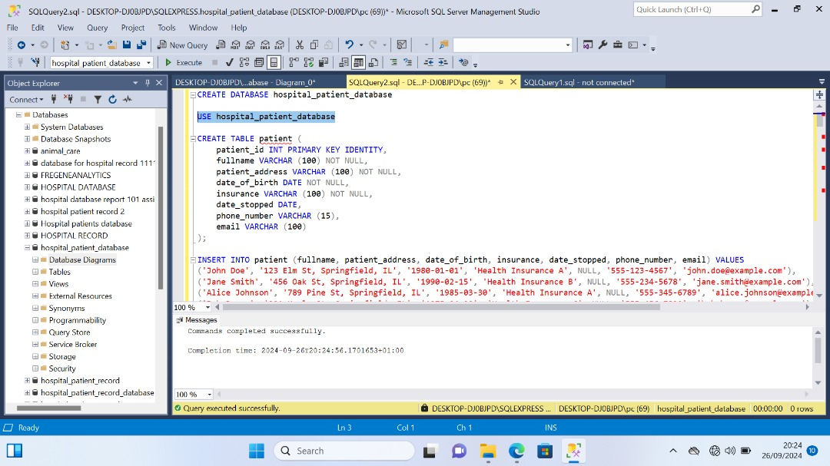

Department Table: This table has two columns, the table is presented to give a tabular description of the hospital departments, the table inludes Department ID column which serves as the PRIMARY KEY and it also has the department names.

In this table the DataTypes used are INTEGERS and VARCHAR datatypes.

Doctors Table: This table includes a DOCTORS ID column which is also the primary key IDENTITY column, the table also includes other columns such as Doctors name column, Doctor’s Specialty column, Department ID column which serves as a foreign key in the table, Doctor’s phone number column and Doctor’s Email column.

Constrains in the table includes PRIMARY KEY INCREMENT constrains and FOREIGN KEY constrain NOT NULL constrain.

Data Types used includes VARCHAR, INT

Medical Records Table: This table gives a tabular description of all data connecting to medical items, Columns in the table includes Medical Record ID which is also the PRIMARY KEY IDENTITY, Patients ID is a column and a FOREIGN key Column from the patients table, Medicine column, Doctors ID is also a FOREIGN KEY column from the doctors table, Last Appointment Date column and Allergies columns.

Constrains includes the IDENTITY INCREMENT constrains and REFERENCES constrain

The Data Types include VARCHAR, INT, DATE datatypes to properly give the table a befitting and comprehensive Overview

Appointments Table: This table is made up of columns such as Appointment ID columns which is also the PRIMARY KEY of the table, Patients ID is a column in the appointment tables that is a FOREIGN KEY from the Patient table, Appointment Date is also found in the table to allow a recording of future appointment date between the Hospital and the patient, Appointment Time is also a column on the table for the purpose of recording the time scheduled for each patients to visit the Hospital, Appointment Status is a column on the table to show the whether or not the Appointment has been ‘Completed’ ‘Canceled’ or ‘Pending’. The last column is Department ID, this is a foreign key from the Department table to reference the table drawing a relationship between the the department table and the appointment table.

The constraints includs the INCREMENT, NOT ULL, DEFAULT.

The Data Types used includes INT, DATE,TIME and VARCHAR data type.

Normalization

First Normal Form (1FN)

- ensure atomicity of value in each column.

Second Normal Forms (2NF)

- Eliminates partial dependencies by ensuring that non key attributes depend fully on the primary key

Third Normal Form (3NF)

- Eliminate transitive dependencies, ensuring date integrity by linking related tables through FOREIGN keys.

CONCLUSION

The Joseph Hospital Database System is a robust and scalable solution designed to improve operational efficiency and healthcare quality, providers with quick access to essential data while ensuring patient data integrity.